All 17 screenshots from the execution of the commands specified in the **project3rootuserscript.sql script**:

**RootCommand 1**:

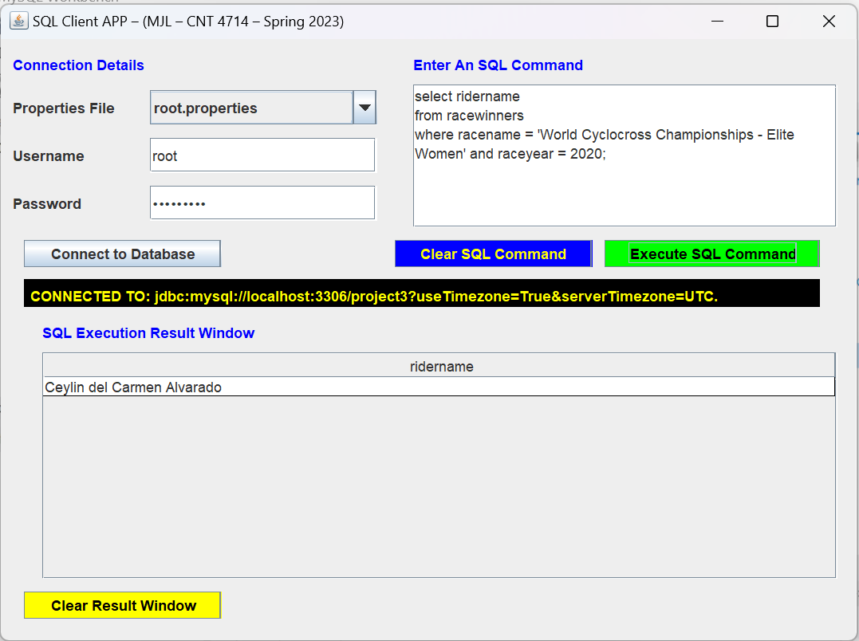

**RootCommand 2:**

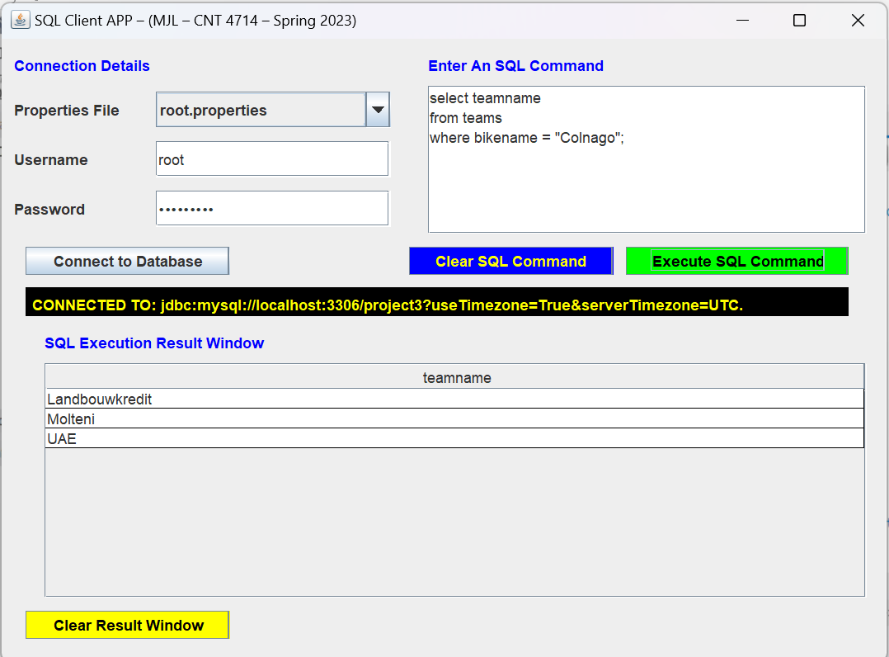

**RootCommand 3:**

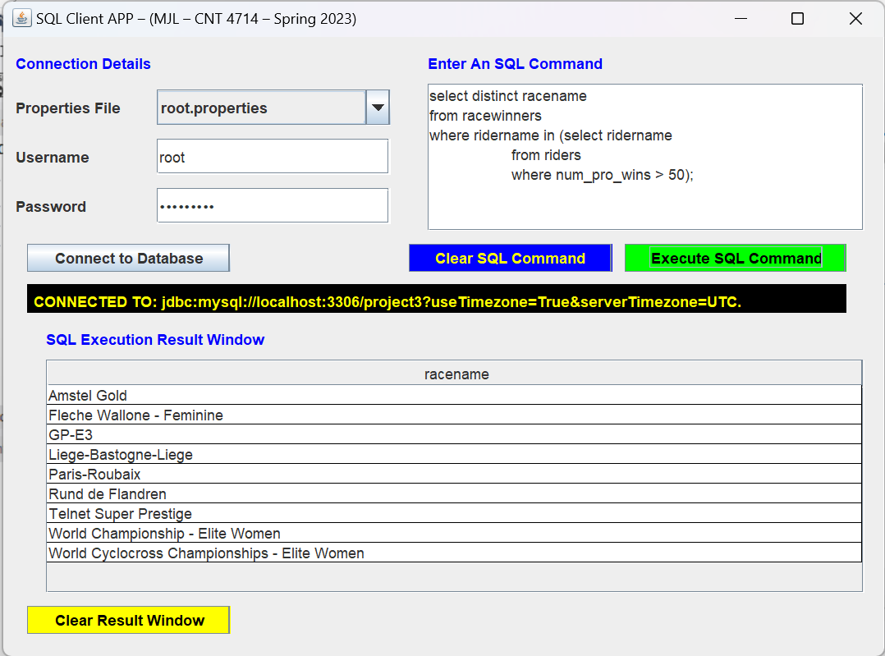

**RootCommand 4:**

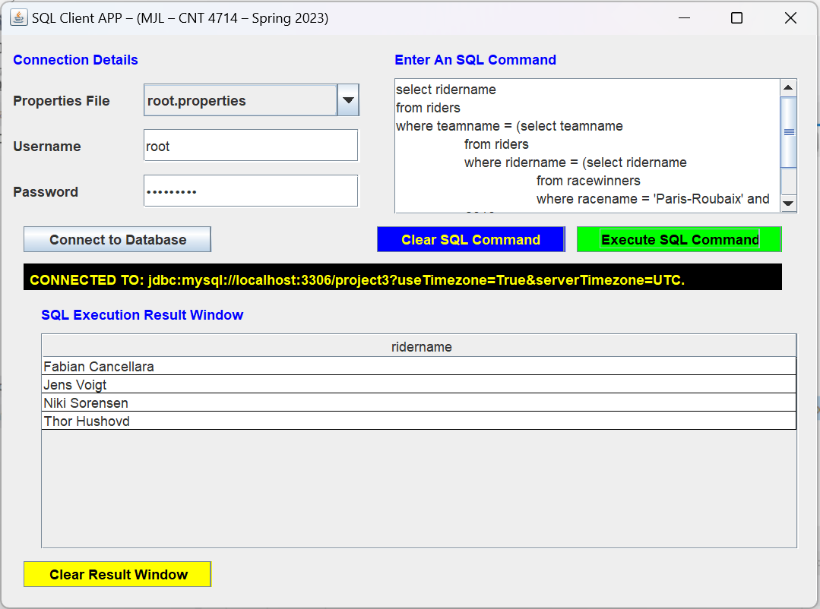

**RootCommand 5A**:

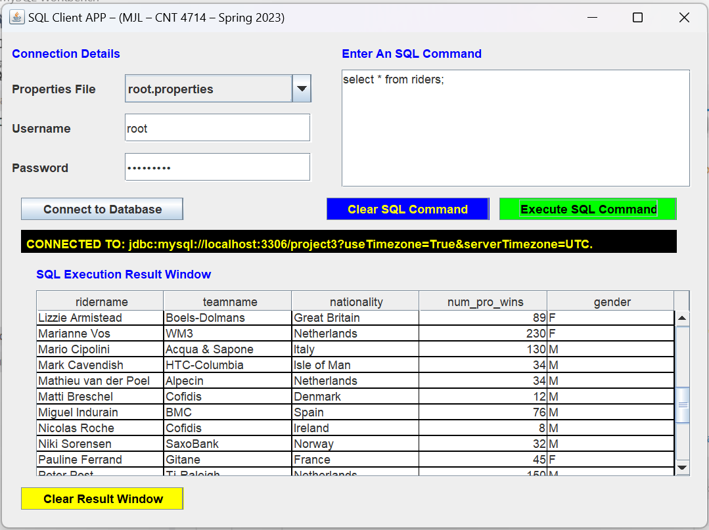

(Mark Renshaw does not exist before)

**RootCommand 5B:**

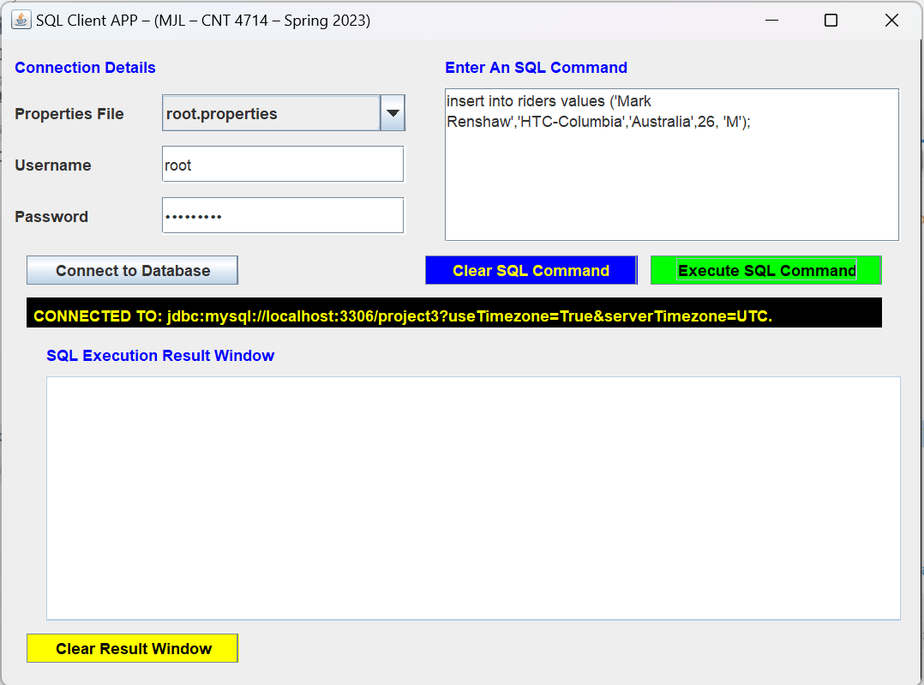

**RootCommand 5C:**

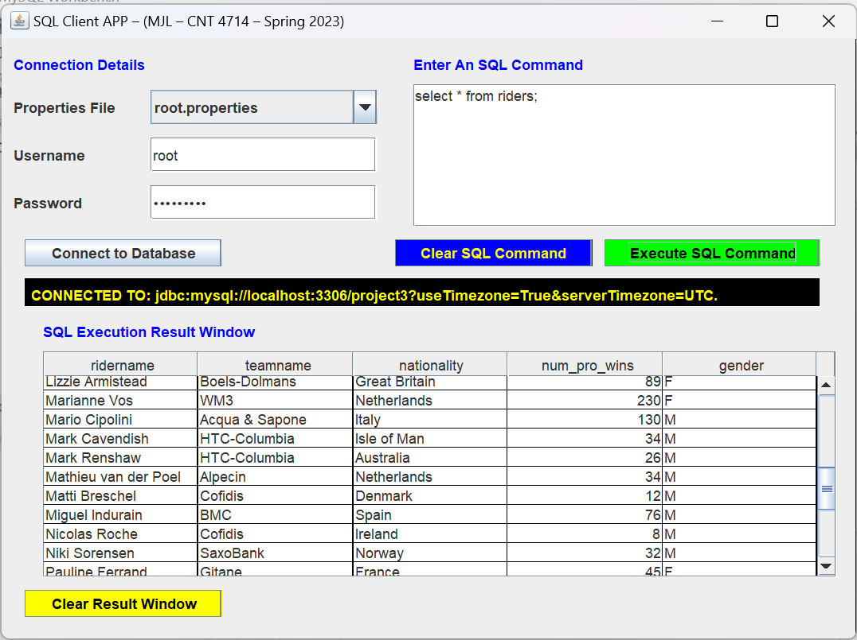

(Mark Renshaw shows in result window)

**RootCommand 6:**

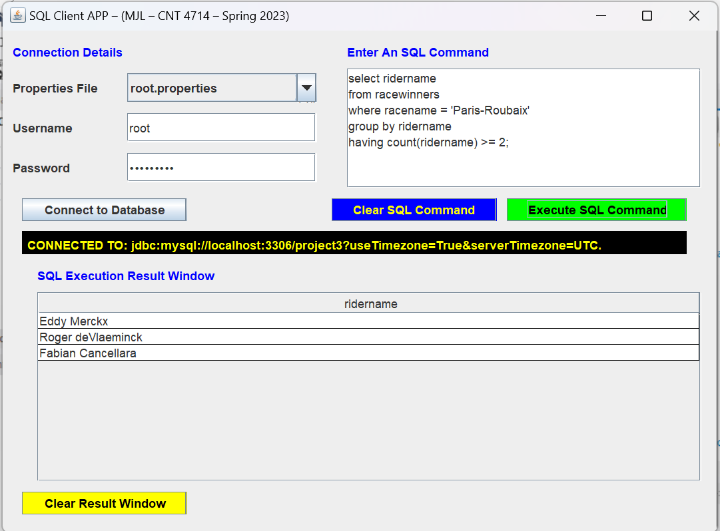

**RootCommands 7A:**

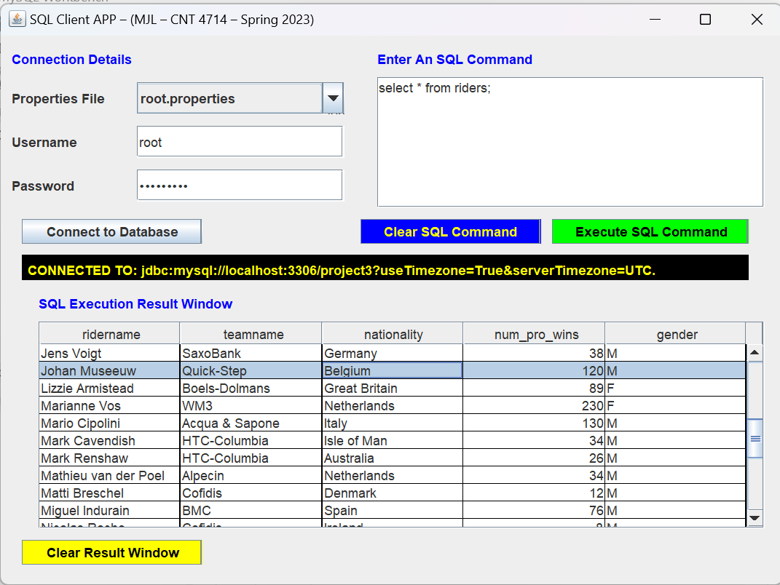

(Belgium riders are contained)

**RootCommands 7B;**

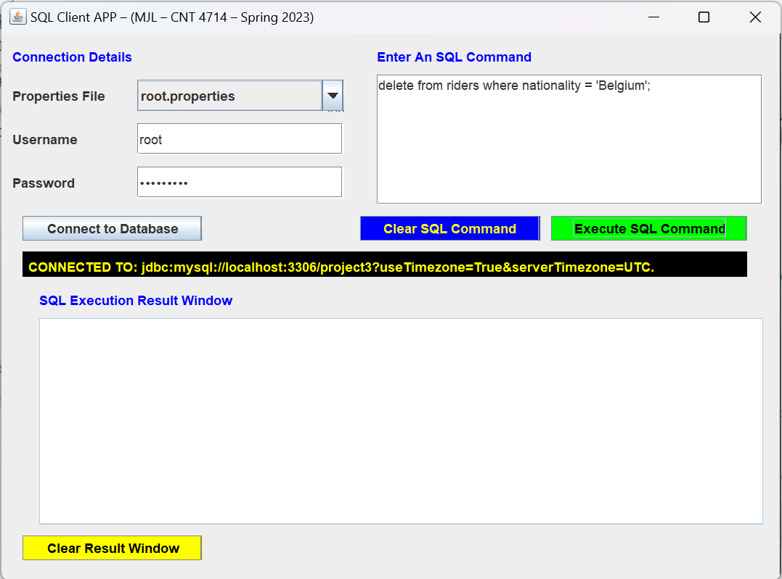

**RootCommands 7C**:

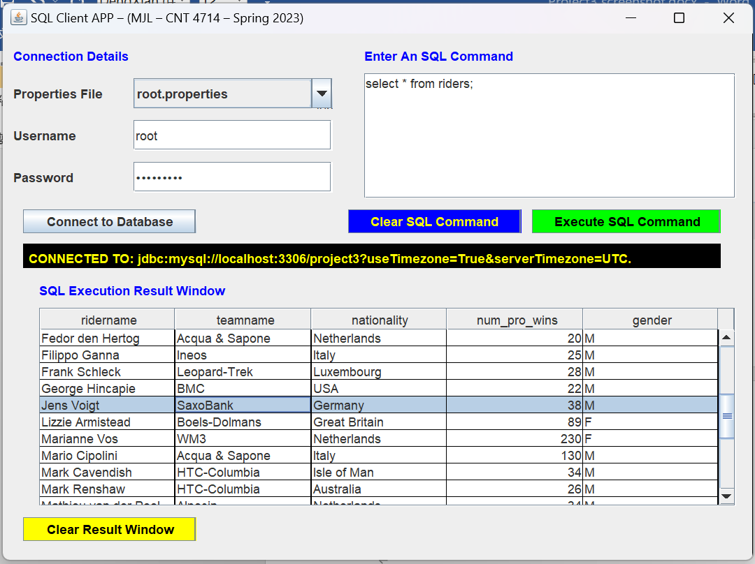

(Belgium riders are deleted)

**RootCommands 8A:**

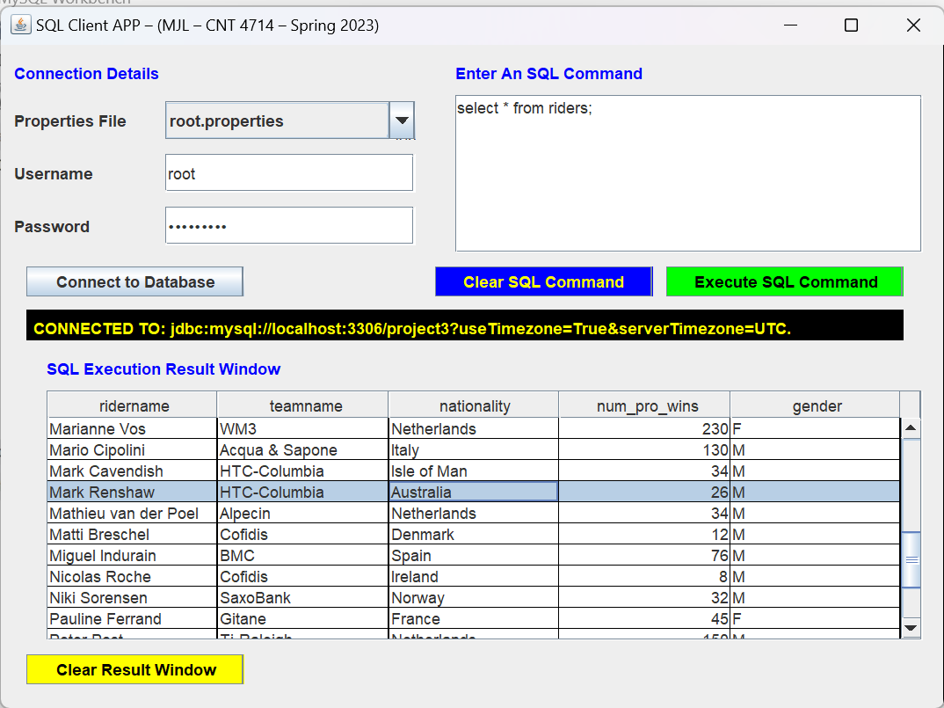

(Mark Renshaw has 26 num_pro_wins)

**RootCommands 8B:**

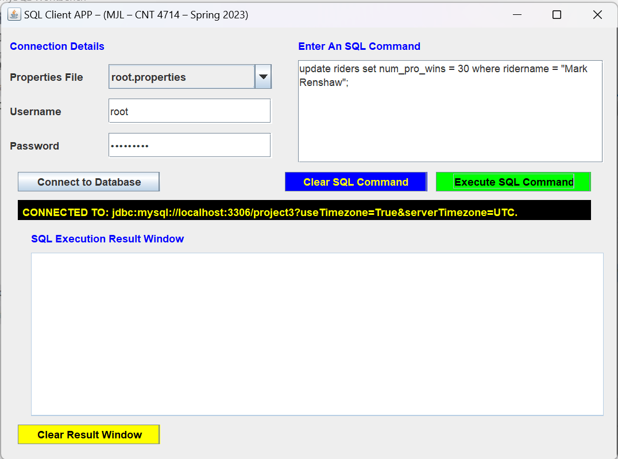

**RootCommands 8C**:

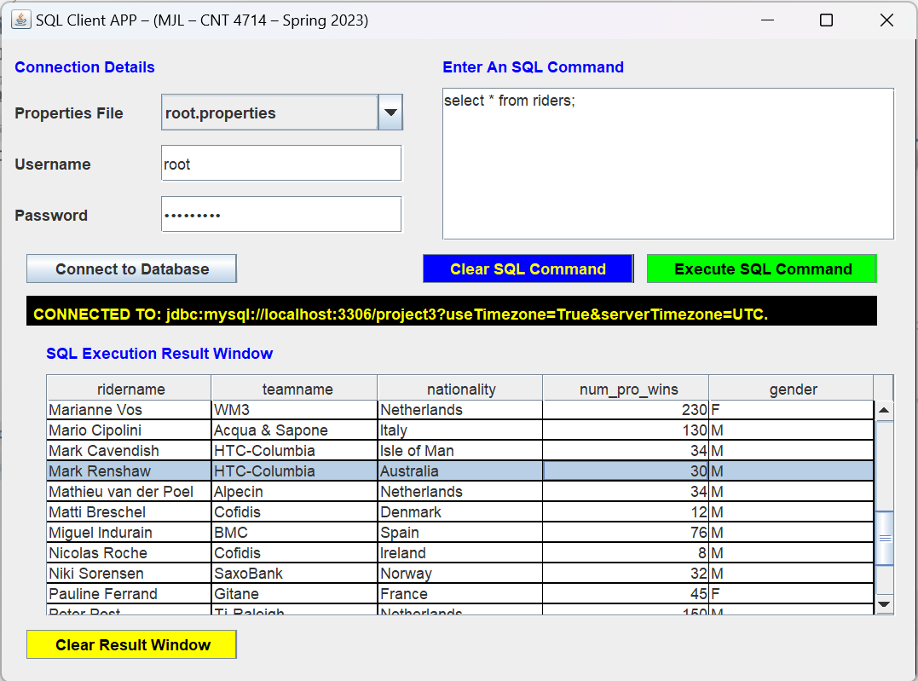

(Mark Renshaw has 30 num_pro_wins currently)

**RootCommand 9:**

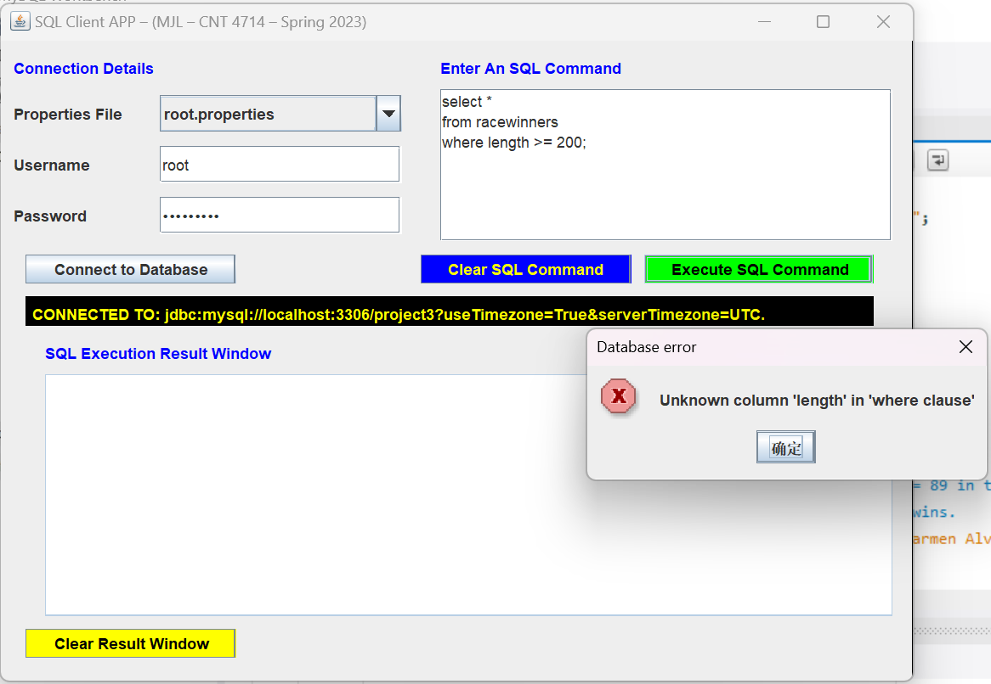

**RootCommands 10A**:

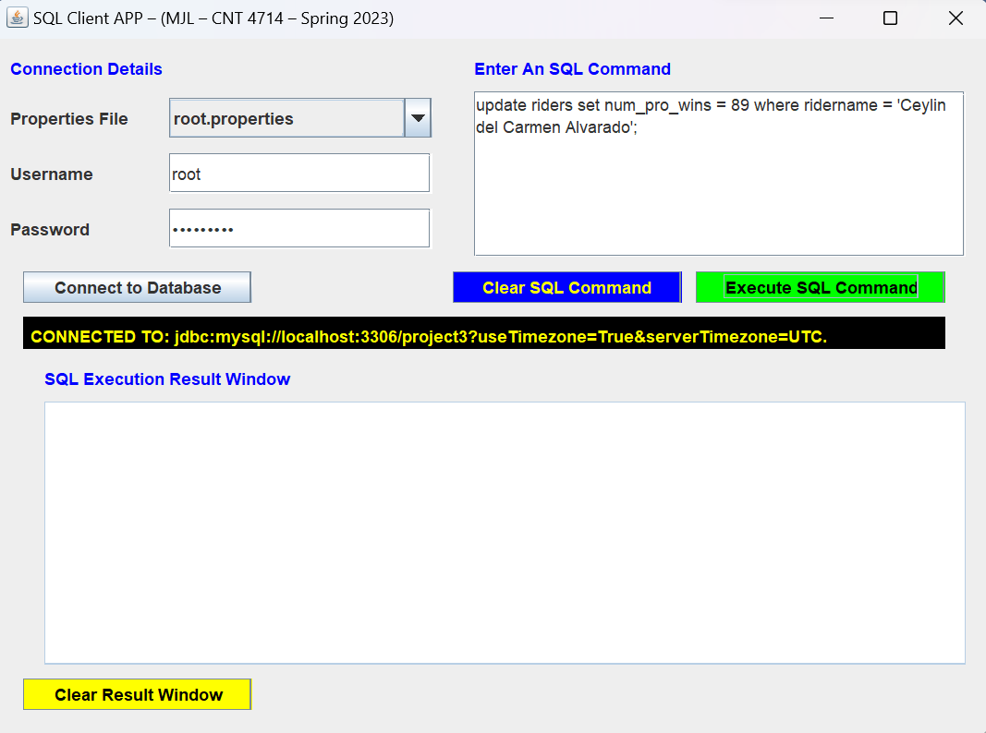

**RootCommands 10B:**

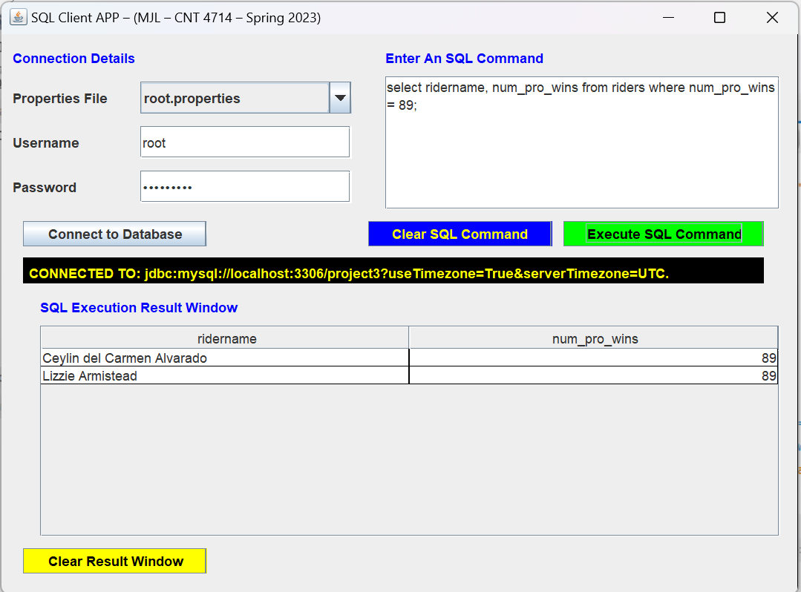

All 11 screenshots from the execution of the commands specified in the **project3clientuserscript.sql script**:

**ClientCommand 1:**

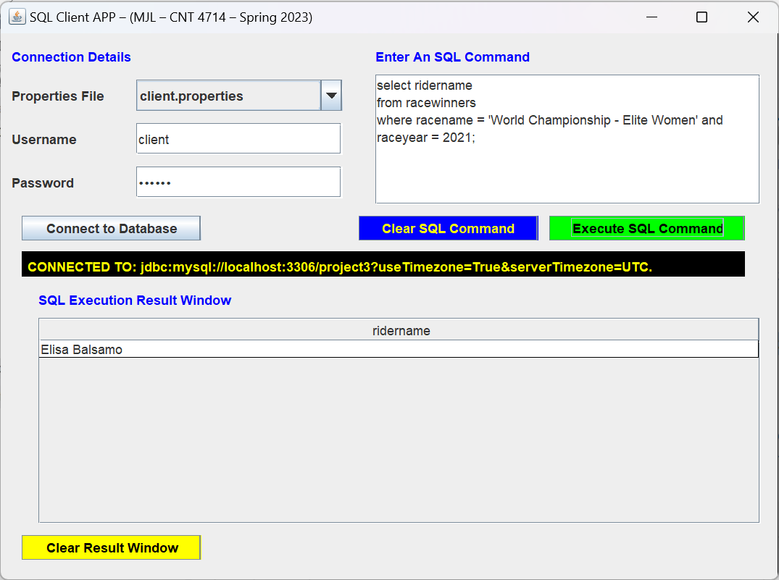

**ClientCommands 2A:**

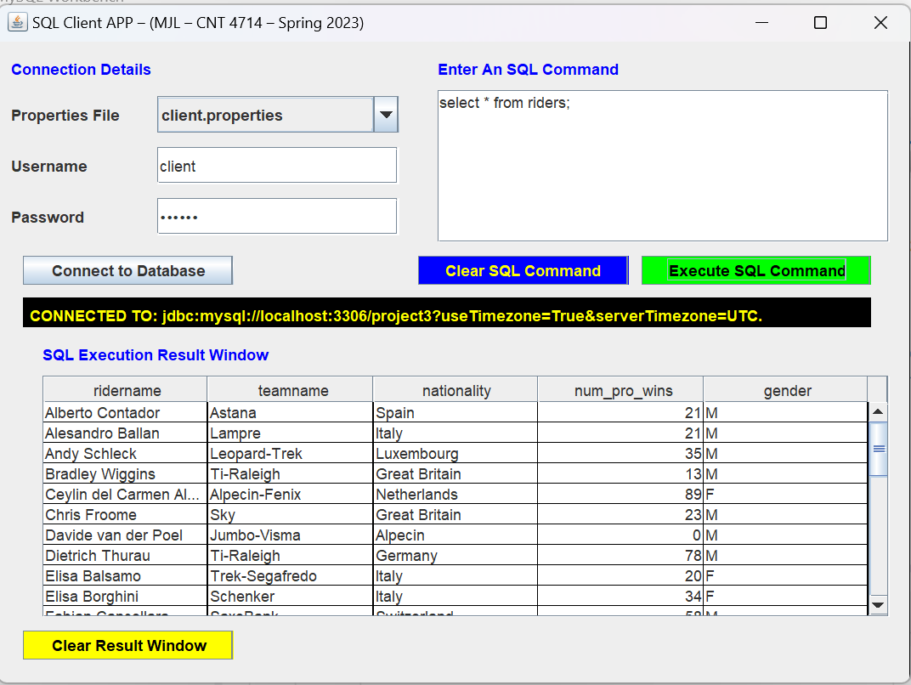

**ClientCommands 2B:**

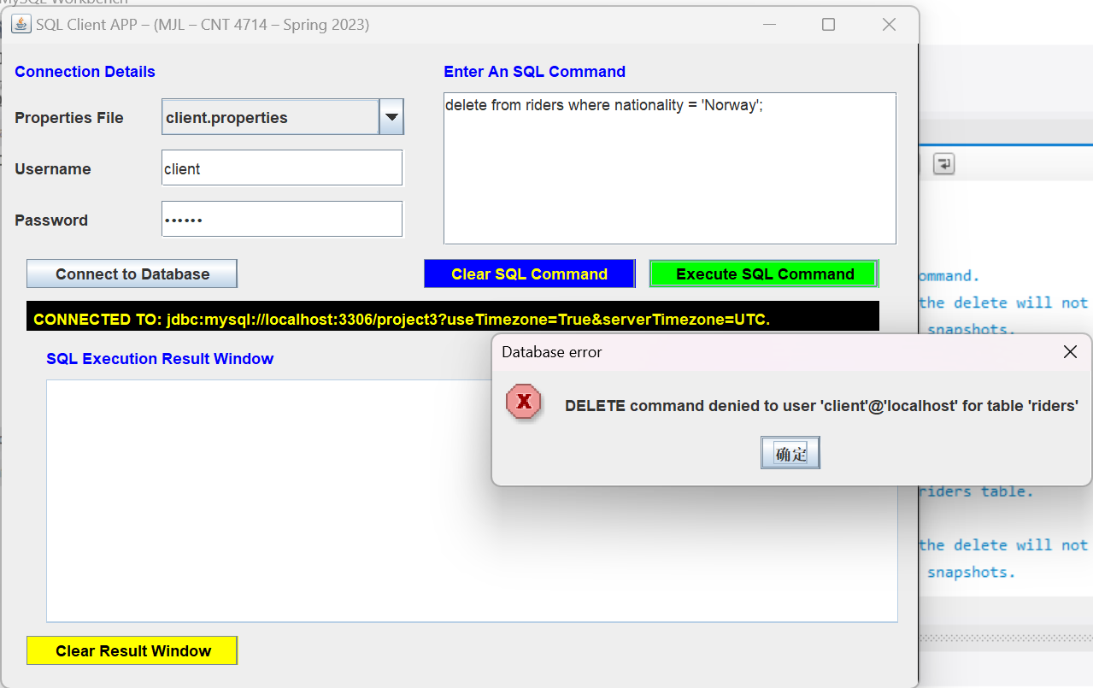

**ClientCommands 2C:**

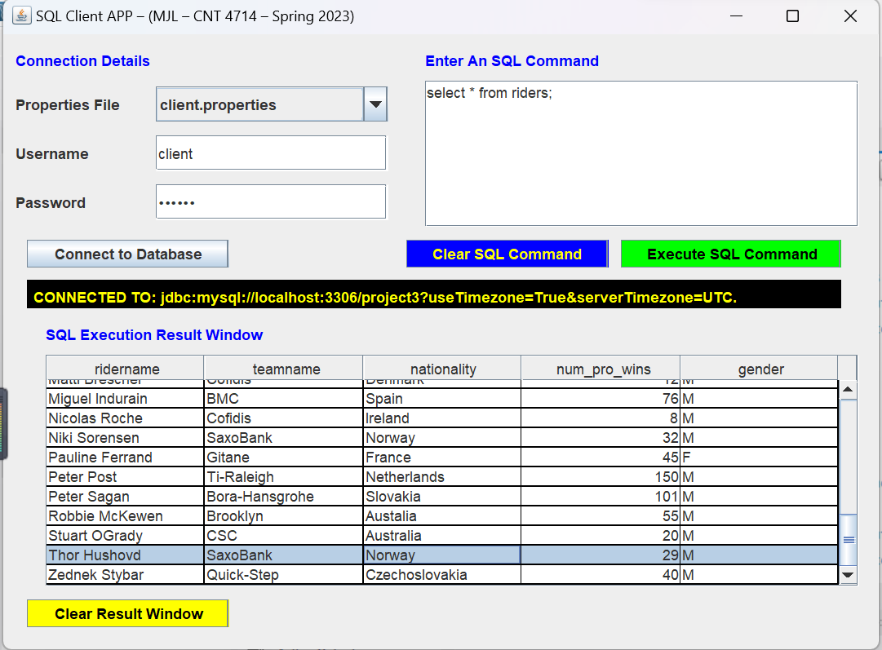

(There are still Norway riders)

**ClientCommands 3A:**

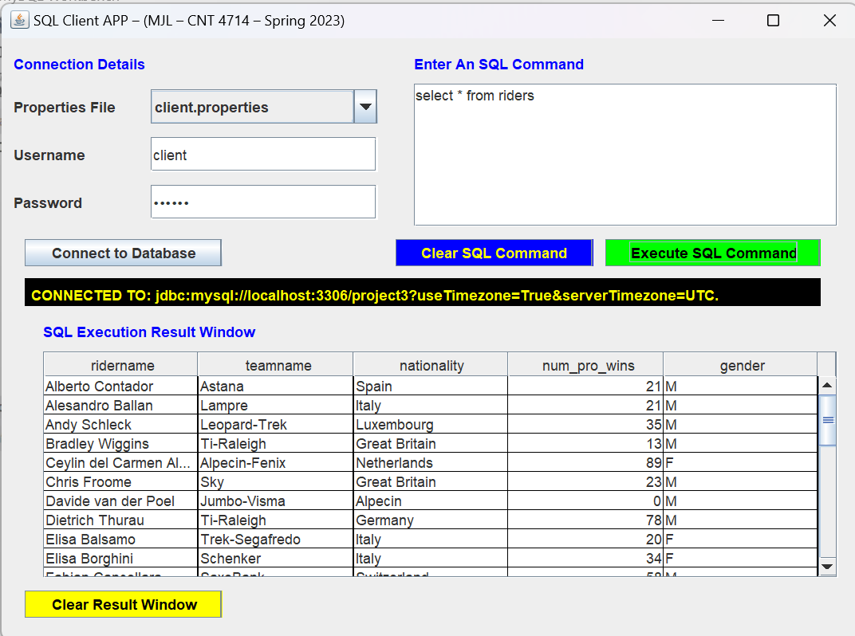

**ClientCommands 3B:**

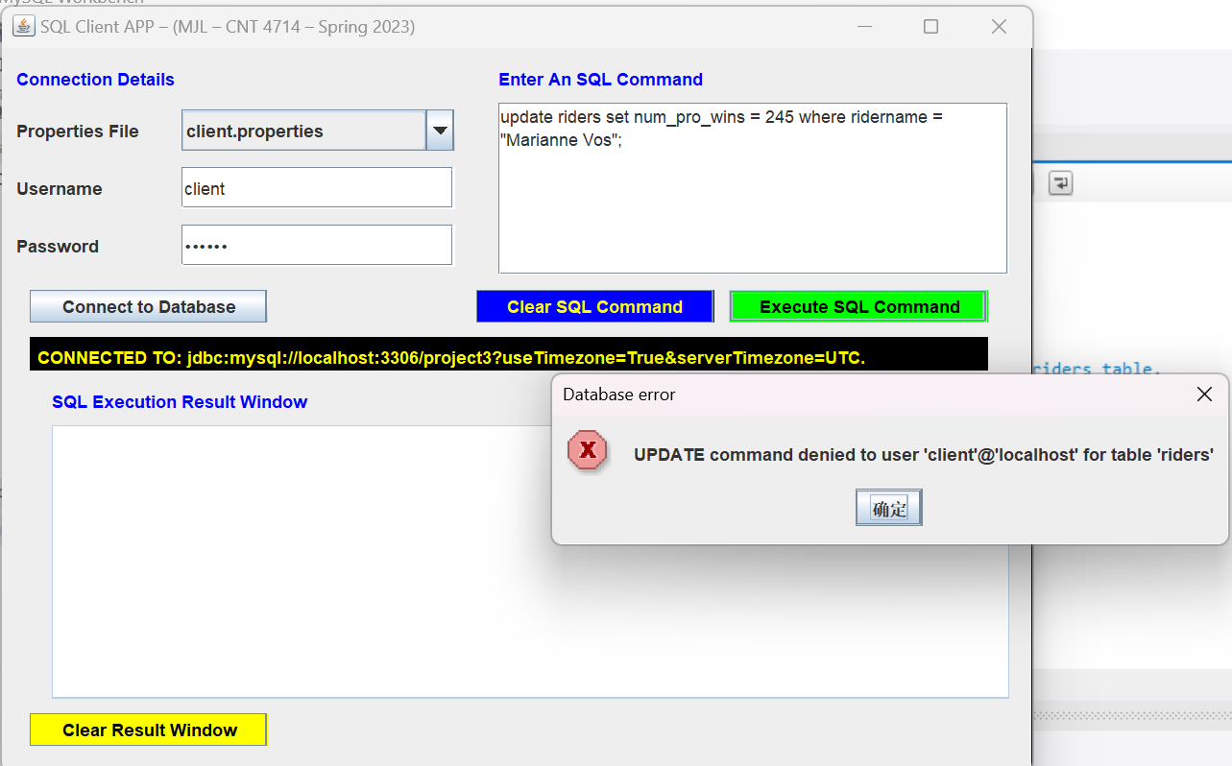

**ClientCommands 3C:**

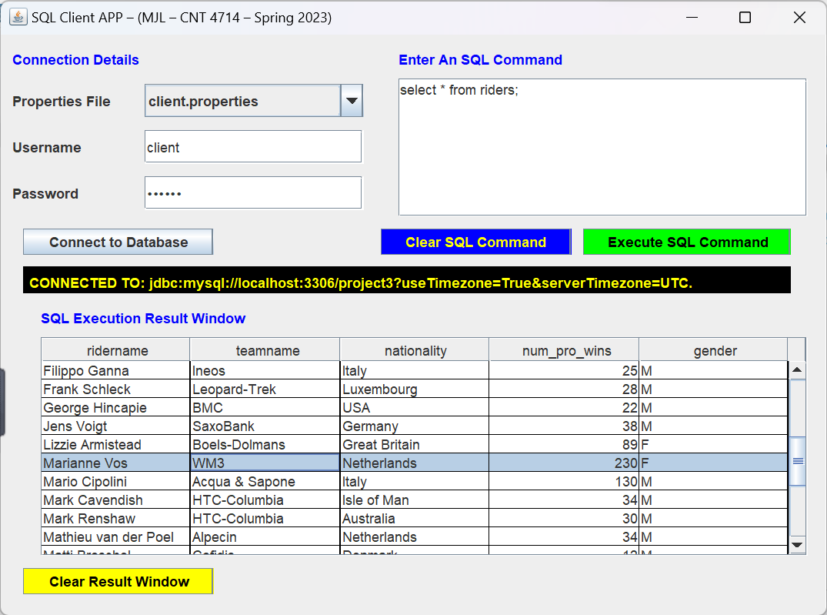

(Marianne Vos still has 230 num_pro_wins)

**ClientCommand 4**:

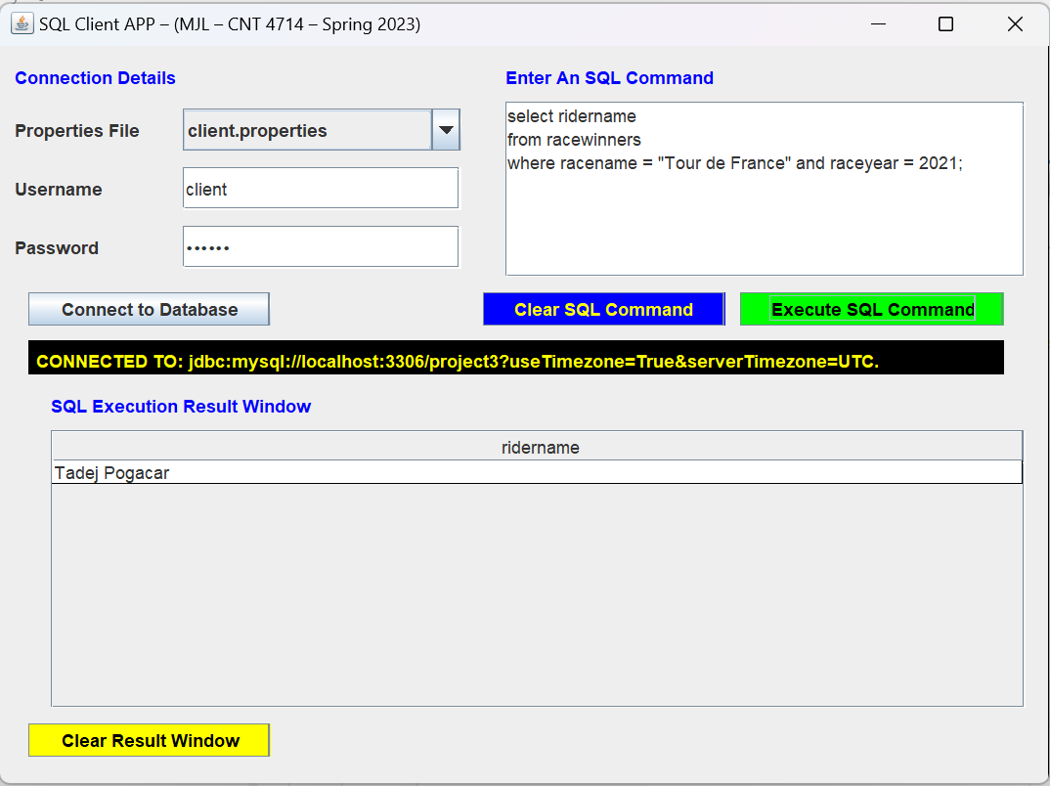

**ClientCommand 5**:

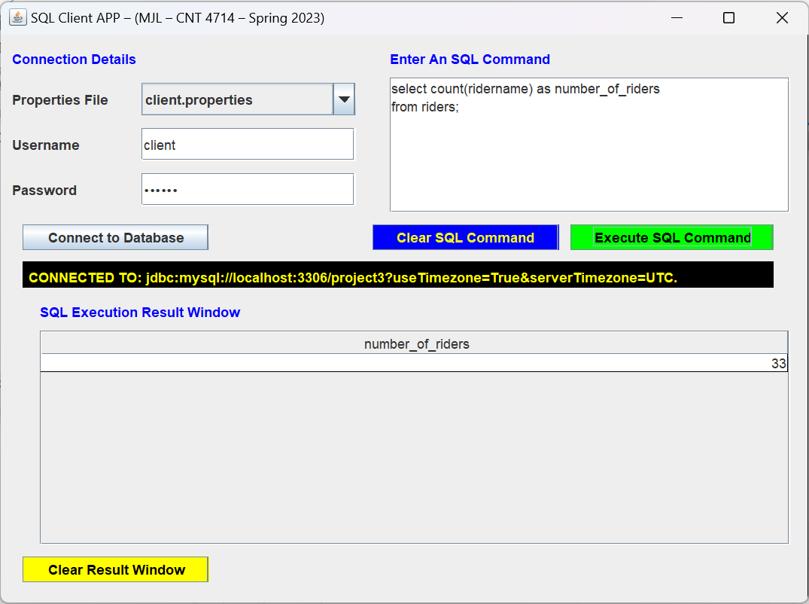

**ClientCommand 6:**

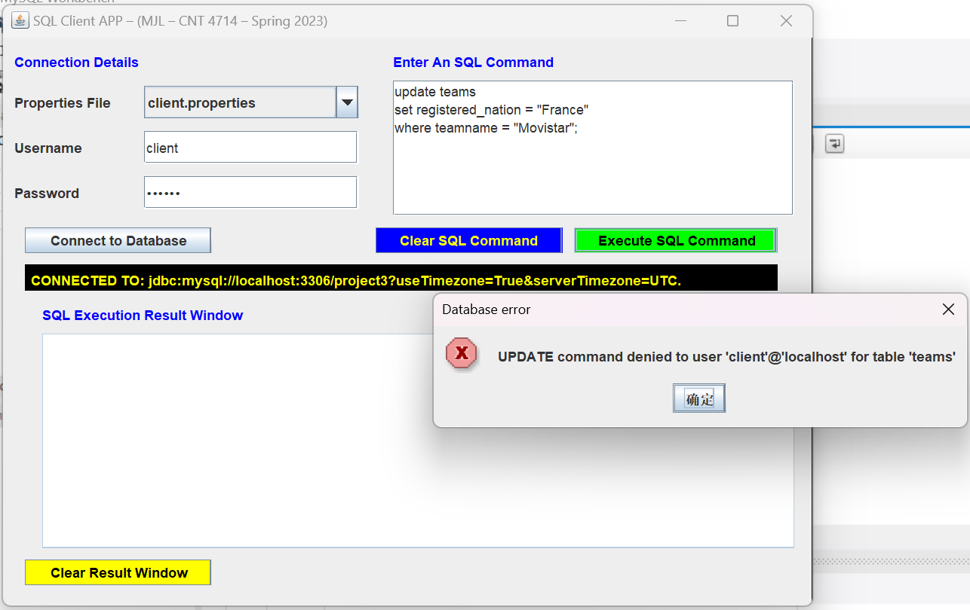

**ClientCommand 7:**

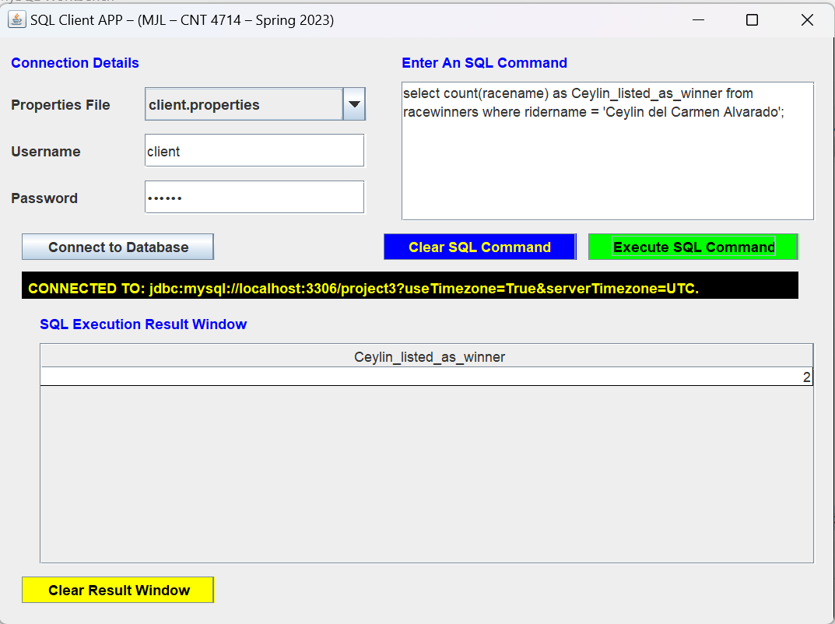

A screenshot showing the final state of the operationscount table after executing the command select * from operationscount; once both the root user and client user command script files have been completely executed:

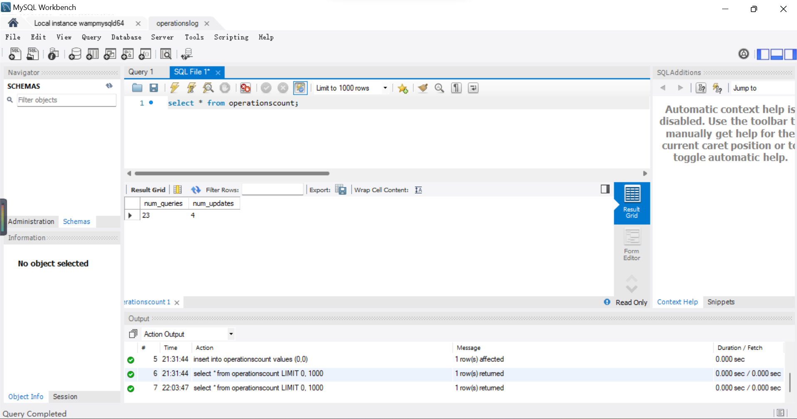

A screenshot showing a mismatch between the user-entered credentials and the selected properties file resulting in no connection to the database being established:

**Wrong root password:**

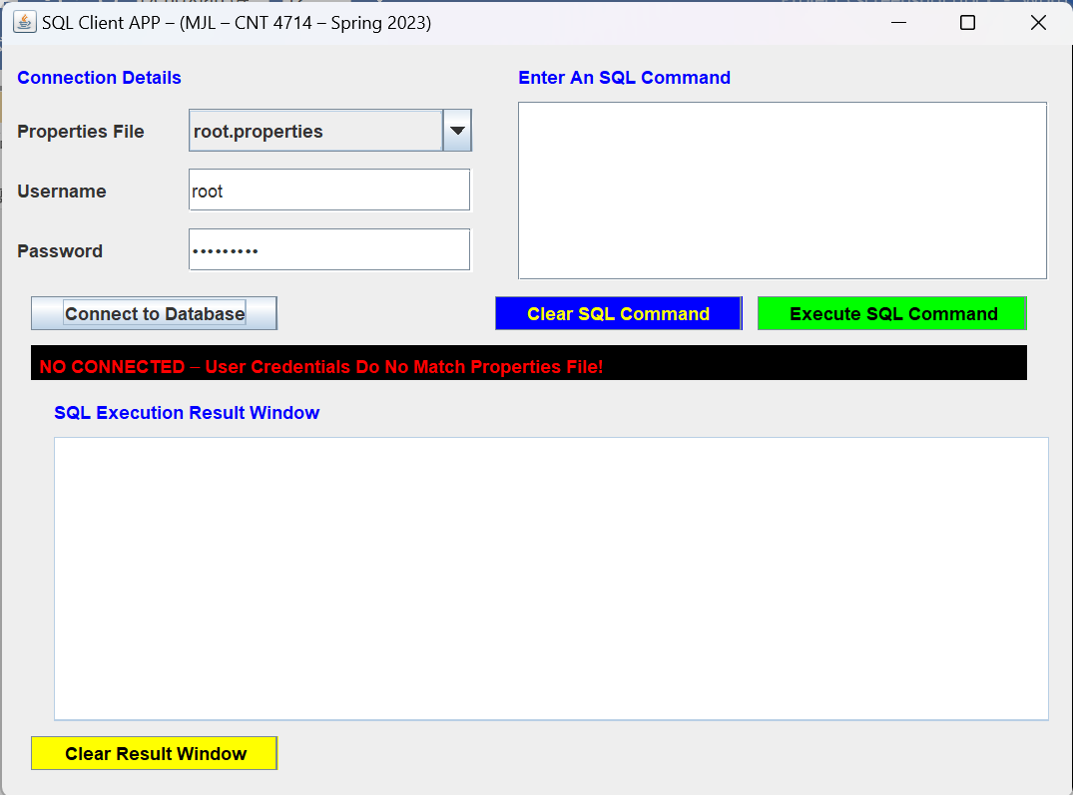

**Wrong client password:**

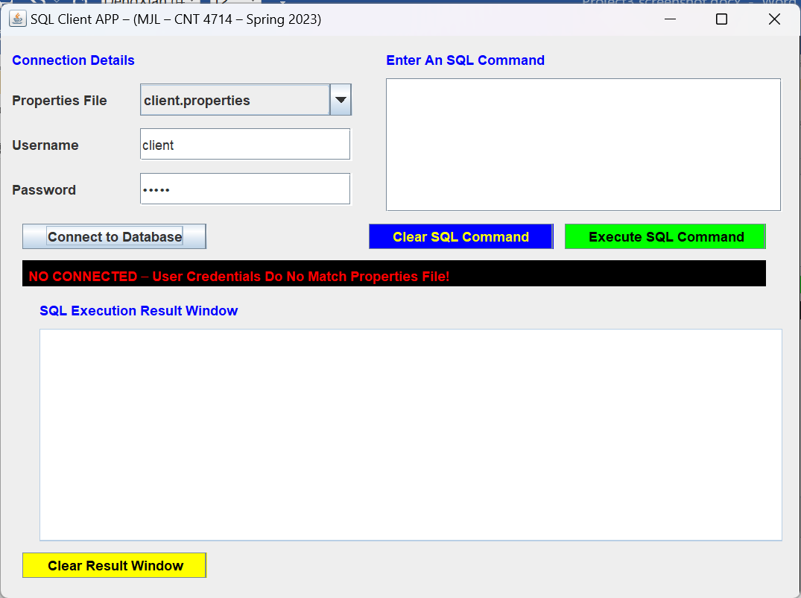

**Use root properties for client:**

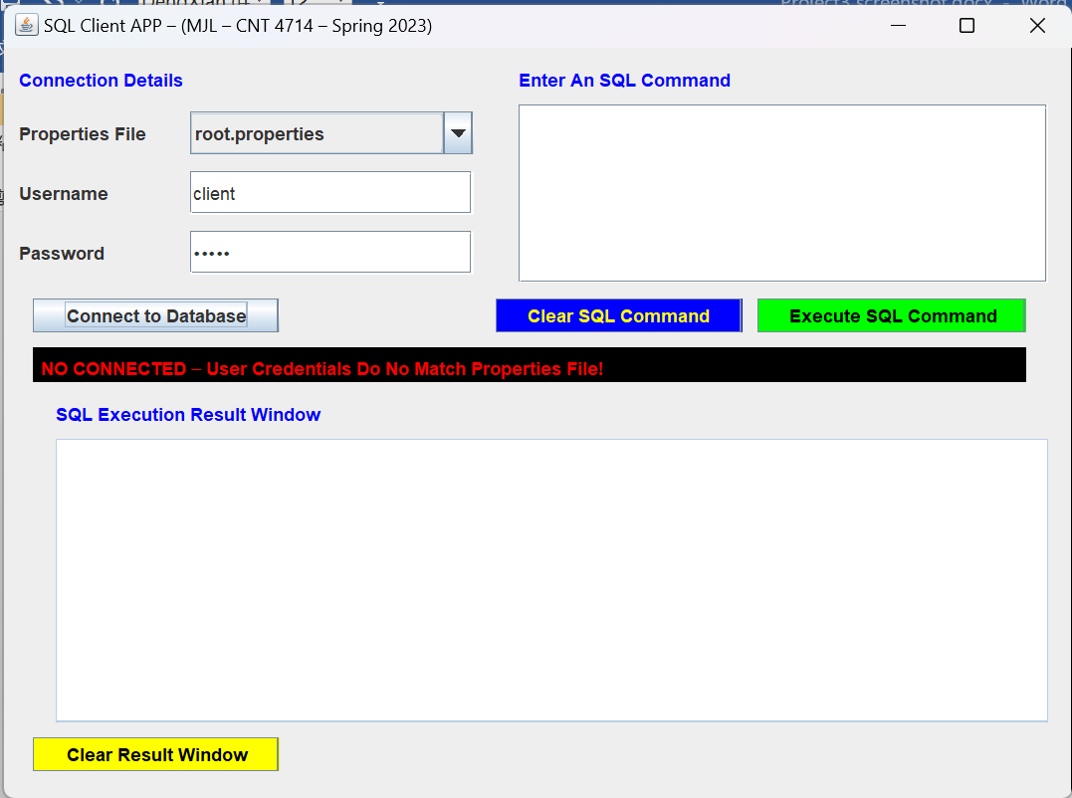

**Use client properties for root:**

